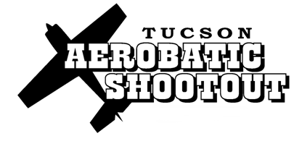

Sponsorship
The 11th Tucson Aerobatic Shootout (TAS) will be held Oct 18-22nd in Tucson, AZ. It is the premier giant scale aerobatic event. The top pilots from around the world are invited to compete in both Precision and Freestyle categories.
The event is followed worldwide by the giant scale community, with great interest in the leading edge equipment used. The event is a showcase for the latest trends in giant scale modeling. The TAS invigorates and fuels the hobby as pilots worldwide strive to emulate what they see at the TAS.
Since the inception of the Tucson Aerobatic Shootout sponsorship from primarily the model airplane industry, has been a primary key to its success. The substantial prize structure that the event is known for, increases media coverage, helps fuel the intense competition, and solidifies the TAS as the premier aerobatic competition in the world. All entry fees and sponsorship funds go directly to the prize pool and cost of producing the event.
While we do everything we can to promote and accommodate our sponsors at and outside of the event, the primary benefit of sponsoring the Tucson Aerobatic Shootout is truly the long term health of the industry where we pursue our livelihood. We hope you will strongly consider being part of the Tucson Aerobatic Shootout!
Here are the various sponsorship levels and event benefits:
Friend of the TAS- $100.00
2017 TAS T-Shirt, Pit Pass
Bronze- $500.00
Banner on Pit area fence, 1 Pit pass, Logo on 2017 TAS T-Shirt

Silver- $1,500.00
Banner at airfield center and 2 on Pit area fence, 2 Pit passes, Logo on 2017 TAS T-Shirt Gold- $2,500.00
Banners at airfield center and 4 on Pit area fence, 4 Pit passes, Logo on 2017
TAS T-Shirt, optional 20x20' tent
Platinum- $5,000.00
Banners at airfield center, 6 banners on Pit fence and vendor area, 6 Pit passes, Prominent Logo on 2015
TAS T-Shirt, Optional 20x20' tent in Vendor area, Logo prominently located on TAS banners, hats, marketing items, etc. Logo on 2015 TAS Banners
Your sponsorship donation can be a combination of cash and product, with a minimum of 50% cash.
Please contact Tony or Dave at info@desertaircraft.com or 520 722 0607 for more details.

